
PUCIT
Punjab University College of Information Technology

First Deliverable
Online Restaurant Food Ordering Service in Train
Version 1.0

Table of Contents

First Deliverable Guide 3
1 Introduction 3
1.1 Project/Product Feasibility Report 3
1.1.1 Technical Feasibility 3
1.1.2 Operational Feasibility 3
1.1.3 Economic Feasibility 3
1.1.4 Schedule Feasibility 3
1.1.5 Specification Feasibility 4
1.1.6 Information Feasibility 4
1.1.7 Motivational Feasibility 4
1.1.8 Legal & Ethical Feasibility 4
1.2 Project/Product Scope 4
1.3 Project/Product Costing 4
1.3.1 Project Cost Estimation By Function Point Analysis 8
1.4 CPM - Critical Path Method 9
1.5 Gantt chart 11
1.6 Introduction to Team member and their skill set 11
1.7 Tools and Technology with reasoning Error! Bookmark not defined.
1.8 Vision Document 11
1.9 Risk List 14
1 Introduction 16
1.1 Systems Specifications Error! Bookmark not defined.
1.2 Identifying External Entities Error! Bookmark not defined.
1.3 Context Level Data Flow Diagram 17
1.4 Capture "shall" Statements 17
1.5 Allocate Requirements 19
1.6 Prioritize Requirements 21
1.7 Requirements Trace-ability Matrix 23
1.8 High level use case diagram 24

First Deliverable Guide

1. Introduction
This is an android application which is designed to order the food online while travelling by train. While travelling a long distance by train the main problem we face is food. To overcome such a problem we want to develop a mobile application through which we are ordering the food online. If the person wants to order food he/her can directly order the food so that the food is delivered directly to your seat and the cash-on-delivery process takes place between the customer and the person who delivers the food to us from the particular restaurant which we order.

1.1 Project/Product Feasibility Report

1.1.1 Technical Feasibility
All of the theory or technology is available to develop this project or product. Usability of the system will provide the benefit of food in train while travelling. The interface is user friendly that provide everyone the opportunity to easily interact with the system and can enjoy meal at time. The people having good English practice and a little bit computer knowledge could easily communicate/interact with the system. All project members possess the technology and technical expertise which are necessarily required for the entire project.

1.1.2 Operational Feasibility
The customers have technical abilities to operate the product. Our observation is that most of the persons have an issue with food available in train and to get the restaurant food the person has to go out to get fresh food which is very time consuming. Some operational benefits of the system are time saving and fresh hygienic food. If customers are not satisfied with the food, then they can give feedback.

1.1.3 Economic Feasibility
Cost estimates include two types first one is Development Cost and the second one is Maintenance and Operation Cost. Due to the technical skills of the project team, cost will be minimized as compared with the benefits and revenue earned by implementing the system. There will be intangible benefits like people can enjoy healthy foods or special food while travelling in train and satisfaction of the customer will be the first priority of this system.

1.1.4 Schedule Feasibility
Hopefully the project will be completed within optimistic time. Every task will be completed within the prescribed limit. All milestones will be completed at the developed schedule and project will be completed within the scheduled time.

1.1.5 Specification Feasibility
All information about the restaurant-customer domain is collected completely accurately. System specifications are clear and can be implemented. Scope of the project is too much clear to develop a robust (without failure) system. There is no ambiguity in the specification of the system. Constraints will also be implemented.

1.1.6 Information Feasibility
As the people would want to enjoy healthy and hygienic meal, while travelling in train. So, they will easily provide their information which are required and related to this application.

1.1.7 Motivational Feasibility
We are creating a highly customized user friendly application that will provide the food service in train. It is beneficial and healthful. This app is easy to use. You can find reliable and special restaurants which are providing food service in train. This app will be popular in the people because of the service it is providing. Our main aim is the satisfaction of the customer by providing quality food service in train.

1.1.8 Legal & Ethical Feasibility
We will try our level best that no illegal development or liabilities arise from this application because all the data is safe on our secure server. This application will be according to the cultural values of the society. Therefore, no violence of the law and culture will be possible.

1.2 Project/Product Scope
Online Restaurant Food Order Service in Train is an application through which passengers in train will be provided with fresh and special restaurant foods while travelling, on their seats. Registered restaurants will provide their food service to passengers on different nearest platforms.
The passenger must register himself for using this application and for acquiring the desired food while travelling. Passengers has to provide their full name, email and number to register himself on this application. Then he will select the required service and food will delivered at the required place. Restaurant must also register itself to use this application. For signing up, Restaurant must fill the form in which it has to provide its name, number, email, address and authentication attested form images. After the restaurant is registered, when a passenger will request for a required food service, it will get request. When restaurant will accept the request, he will receive the passenger’s information and status of train.
The restaurant will send a delivery person/worker to that person and passenger will get the required food and will pay the cash payment. After enjoying meal, the passenger can give feedback or complain direct to manager.

1.3 Project/Product Costing

1.3.1 Project Cost Estimation By Function Point Analysis

Type of Components |  | Complexity of Components
 |  | Low | Average | High | Total
External Inputs |  | 5*2 | 5*5 | 4*7 | 63
External outputs |  | 3*3 | 3*6 | 2*8 | 43
External Inquiries |  | 3*7 | 4*8 | 2*9 | 71
Internal Logical Files |  | 4*6 | 1*9 | 1*11 | 44
External Interface Files |  | 4*4 | 3*6 | 1*9 | 43
 |  |  | Total Number of unadjusted function Points |  | 264
 |  |  | Multiple Value Adjustment Factor |  | 35
 |  |  | Total Adjusted Function Points |  | 264

Number of External inputs:
- Low
- Passenger Profile Update
- Restaurant Profile Update
- Passenger Login
- Restaurant Login
- Admin Login
- Average
- Passengers Signup
- Restaurants Signup
- Passengers Feedback
- Search for Restaurants
- Search for menu
- High
- Passenger request for order
- Restaurant’s response
- Passenger receipt of order
- Passenger make Payment

Number of outputs:
- Low
- Show restaurant’s menu
- Show total bill
- Show reviews
- Average
- Show history of registered restaurants
- Show registration requests
- Show restaurant Details
- High
- Show restaurants categorized by place
- Show restaurant Profile

Number of External inquiries:
- Low
- Train number
- Train location
- PNR number

- Average
- Login Verification
- Restaurant authentication proof
- Specific food category
- Restaurants on specific location
- High
- Restaurant Status
- Food Order Status

Number of files:
- Low
- Passengers
- Restaurants
- Complaints
- Reviews
- Average
- Restaurant contact information
- High
- History

Number of external interfaces:
- Low
- Login
- Restaurant profile
- Reviews
- Update Profile
- Average
- Sign Up
- Orders status/information
- History
- High
- Main Page

General System Characteristics | Rates
Data communications | 2
Distributed data processing | 2
Performance | 3
Heavily used configuration | 1
Transaction rate | 1
On-Line data entry | 3
End-user efficiency | 5
On-Line update | 4
Complex processing | 3
Reusability | 3
Installation ease | 2
Facilitate change | 3
Total | 32

Assuming
- Average Productivity = 47 Function Points per Month
- Labor Rate = Rs 11,000/Month

1.3.2 Size of Project

FP est. = Count Total * [ 0.65 + 0.01 * (Fi)]
FP est. = 264 * [0.65 + 0.01 * (32) ]
FP est. = 256.08

1.3.3 Cost/FP

Cost/FP = 11,000/47
Cost/FP = 234.042

1.3.4 Total Project Cost

Total Project Cost = Size of Project * Cost/FP
Total Project Cost = 264 * 234.042
Total Project Cost = 61,787.23

1.3.5 Total Estimated Effort

Total Estimated Effort = Size of Project/ Avg Productivity
Total Estimated Effort = 264/47
Total Estimated Effort = 5.62

1.4 CPM - Critical Path Method

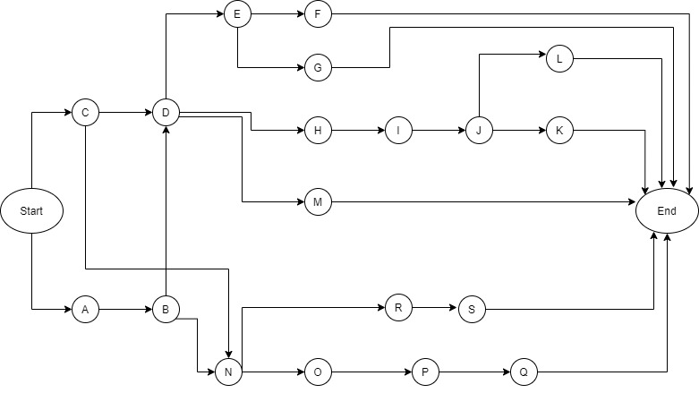

1.4.1 Activities and Duration

 | Activity | Immediate Predecessor | Duration  (Days)
A | Register request | None | 5
B | Verification | A | 5
C | Login | None | 3
D | Restaurant main | B,C | 15
E | Restaurant Items | D | 3
F | Restaurant Selected Items | E | 3
G | Restaurant Items Details | E | 3
H | List Orders | D | 5
I | Pending Orders | H | 4
J | Orders Details | I | 4
K | Pending status | J | 5
L | Train Status | J | 5
 | Reviews | D | 5
N | User Main | B,C | 15
O | Restaurant List | N | 5
P | Restaurant Items | O | 10
Q | Items Lists | P | 5
R | Order Details | N | 7
S | Modify Order | R | 3

1.4.3 Critical Path Factors

 | Activity | Duration  (days) | ES | EF | LS | LF | TS | FS
A | Register request | 5 | 0 | 5 | 0 | 5 | 0 | 0
B | Verification | 5 | 5 | 10 | 5 | 20 | 5 | 0
C | Login | 3 | 0 | 3 | 0 | 15 | 0 | 0
D | Restaurant Main | 15 | 3 | 18 | 15 | 18 | 12 | 0
E | Restaurant Items | 3 | 18 | 21 | 18 | 21 | 0 | 0
F | Restaurant Selected Items | 3 | 21 | 24 | 21 | 24 | 0 | 0
G | Restaurant Items Details | 3 | 21 | 24 | 21 | 24 | 0 | 0
H | List Orders | 5 | 18 | 23 | 19 | 23 | 1 | 0
I | Pending Orders | 4 | 23 | 27 | 23 | 27 | 1 | 0
J | Orders Details | 4 | 27 | 31 | 27 | 31 | 0 | 0
K | Pending Status | 5 | 31 | 36 | 31 | 36 | 0 | 0
L | Train Status | 5 | 31 | 36 | 31 | 36 | 0 | 0
M | Reviews | 5 | 18 | 23 | 18 | 23 | 0 | 0
N | User Main | 15 | 10 | 25 | 20 | 25 | 10 | 0
O | Restaurant List | 5 | 25 | 30 | 25 | 30 | 0 | 0
P | Restaurant Items | 10 | 30 | 40 | 35 | 40 | 0 | 0
Q | Items Lists | 5 | 40 | 45 | 40 | 45 | 0 | 0
R | Order Details | 7 | 25 | 32 | 29 | 32 | 4 | 0
S | Modify Order | 3 | 32 | 35 | 32 | 35 | 0 | 0

1.4.4 Critical Path:

Start→A→B→D→H→I→J→K→end

1.5 Gantt chart

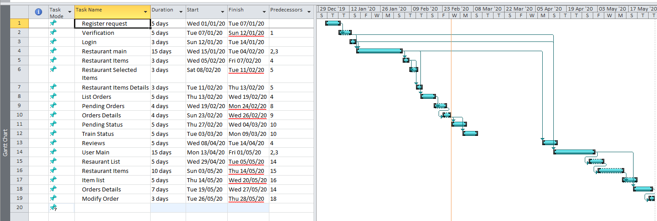

1.6 Introduction to Team member and their skill set

1.6.2 Member Skills

Team Leader: Sidra khan

Team Members:
Name | Registration # | Email Address | Signature
Sidra Khan | MCSF18M035 | Mcsf18m035@pucit.edu.pk
Ayesha Zafar | MCSF18M023 | Mcsf18m023@pucit.edu.pk
Amna Parvaiz | MCSF18M047 | Mcsf18m047@pucit.edu.pk
Arooj Jamil | MCSF18M037 | Mcsf18m037@pucit.edu.pk
Sibgha Mushtaq | MCSF18M010 | Mcsf18m010@pucit.edu.pk

1.6.1 Member Skills

a. Sidra khan
- Good in development and testing
- Good Skills in database management
- Proficient in learning new technologies

b. Sibgha Mushtaq
- Good Analytical skills
- Flexibility with environment
- Proficient in Communication and Documentation (Oral and written) of the project.

c. Ayesha Zafar
- Good in development and testing
- Good in problem solving
- Good management skills

d. Amna Parvaiz
- Good in development and testing
- Good analytical skills
- Proficient in Project Management

e. Arooj Jamil
- Good in web designing / Front end development
- Proficient in analytical skills
- Flexibility with environment

Tools and Technology with reasoning

We will be using following tools and technologies for developing Part At Ease app

1.7.1 Android Studio
We will use it as an IDE for Android app. Android Studio is the official integrated development environment for Google's Android operating system, built on JetBrains' IntelliJ IDEA software and designed specifically for Android and IOs development. It is helpful for Android development process.

1.7.2 Software Development Kit (SDK)
The main tool for the Android is software development kit which is shortly denoted as SDK. Additionally, it will offer the application development process to the developers along with some useful environments like writing, testing and debugging mobile applications.

1.7.3 Android Virtual Device (AVD)
AVD is an Android Emulator that will ensure that testing and debugging process will be done smoothly and help us in simulating the features of OS as well as device on our system. It provides a completely simulated device to run and test the application without having to attach a real android device to the computer. AVD helps us to test our app on any kind of device like Nexus 5, OnePlus, etc.

1.7.4 Lucid Chart
Lucid Chart is a Unified Modelling Language (UML) design tool intended for visual modelling and component construction of enterprise-level software applications. We will be using it for creating UML diagrams for our project deliverables.

1.7.5 Microsoft Project 2016
Microsoft Project is project management software, which is designed to assist project managers in developing plans, assigning resources to tasks, tracking progress, managing budgets and analyzing workloads. We will be using this software for developing schedules, critical path analysis, managing resources and creating Gantt chart.

1.7.6 Microsoft Word 2016
Microsoft Word is a very efficient and reliable word processor. We will be using this tool for our documentation purposes.

1.7.7 Adobe illustrator
It will be used to create required graphics for the application.

1.7.8 Host (or Development) Platform(s)
Android Studio, Android Virtual Device, Android Mobile Phones

1.7.9 Target Platform
Android Mobile devices
Programming languages: We will be using Java for our application development.
Database server: Firebase will be used throughout the project. Firebase provides a real-time database and backend as a service. The service provides application developers an API that allows application data too be synchronized across clients and stored on Firebase’s cloud. It provides client libraries that enable integration with android applications.
IDE: Android Studio
Client Side: Java

1.8 Vision Document

1.8.1 Introduction
This app will provide fresh food service in train to passengers. The passenger can order food from nearby restaurants to avoid unhygienic train catering food service while travelling. User can click from app, book order by giving some required information.
- Convenience – this app is simple, easy to use and will provide services to passengers during travel in train.
- Eligibility – Every passenger can register and get our services.
- Enjoyable – Passengers will enjoy special food of restaurants at their seats.
1.8.2 Business Requirements

1. Registration
Only registered users only could get our services. So a user must be able to register himself to the system by requesting for registration. User should provide his personal details in the registration request process. Verification code will be send to his email or phone which he will enter to complete the registration process.

2. Passenger Side
If the customer wants to order, he will request for the food to his favourite restaurant. He can also see the price and the information of restaurant along with the feedback. He can select the desired food items from the list and confirm the order. Passengers can give the feedback about the restaurant. Passengers can complain about the service. Passenger can also cancel the order within the specific time limit.

3. Restaurant Side
Restaurant will get orders request direct from the passengers. The restaurants will get passenger seat information, name, email, seat number and location. After accepting the orders, the restaurant will send a delivery person to deliver food at the requested location in train and get cash payment. Restaurant can decline request of order within specific limit of time.

4. Server Side
All the information about customer and restaurants will be saved and managed by server side. Server side will take care of everything like handling complains and other software and hardware related issues. Server side is managed by Admin.

1.8.3 Product Overview/Solution
- Our system is completely independent.
- It provides food services in train.
- It is best for people who want to have a healthful journey while travelling in train for long distances.
- Restaurants will also earn profit and popularity.

1.8.4 Major Features
- Registration
- Confirmation process by different techniques such as SMS and email
- User verification
- Passenger can Book/Modify order for food
- Restaurants will provide the food service in train
- Passengers can give feedback
- Passengers can complain
- Highly secured database

1.8.5 Scope
This app is meant to provide fresh restaurant special food to passengers while travelling in train. The food will be provided by restaurants at the seats of passengers. In this way, the passengers will have alternate of unhygienic food of train catering service. This app will work for both restaurants and passengers. This app will not work if its server is down. The admin will be managing the backend verification and information.

1.9 Risk List
- App will not work if you do not have an internet connection.
- Network related problems may arise during sending and receiving messages.
- Server down.
- Risk of false information from the user.
- Risk of late orders.
- Risk of losing public trust.
- Risk of wastage of food in case of late arrival.

*********************REQUIREMENTS ENGINEERING*********************

1.Introduction
This is an android application which is designed to order the food online while travelling by train. While travelling a long distance by train the main problem we face is food. To overcome such a problem we want to develop a mobile application through which we are ordering the food online. If the person wants to order food he/her can directly order the food so that the food is delivered directly to your seat and the cash-on-delivery process takes place between the customer and the person who delivers the food to us from the particular restaurant which we order.
Scope of the System
This app is meant to provide fresh restaurant special food to passengers while travelling in train. The food will be provided by restaurants at the seats of passengers. In this way, the passengers will have alternate of unhygienic food of train catering service. This app will work for both restaurants and passengers. This app will not work if its server is down.

1.1 Systems Specifications
The purposed system must fullfil following requirements as follow:

1. Order for food service

- Only registered passengers can order food. So, passengers must register themselves to the system. Passengers should provide their name, phone no., seat no., berth no. and mail id for registration.
- After registration user can login and can request for food service.

2. Provide Service
Only registered restaurants can provide their service. So, restaurants must be able to register themselves to the system by requesting for registration. After registration restaurants can accept the order request from passengers and provide their service.

3. Admin Side
Admin side control all the data, register all passengers and restaurants. It also fixes the hardware and software issues and receive complains, comments and act accordingly.

4. Feedback
Passengers can also give the feedback about the food services as they get. Passengers can see the other people reviews about the restaurants, so it will be easy to choose the best restaurant after reading reviews.

1.2 Identifying External Entities or Actors

1.2.1 Perform Refinement
- Passenger
- Restaurant
- Service request
- Feedback
- Provide

1.3 Context Level Data Flow Diagram

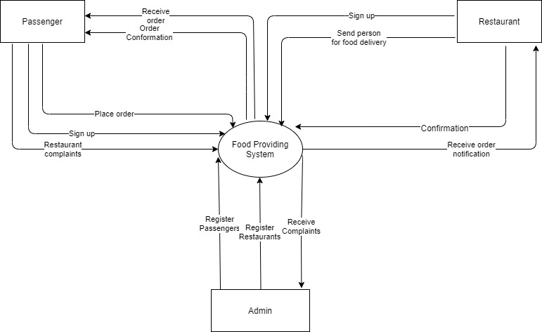

1.4 Capture "shall" Statements and the external entities (Actors)

Para # | External Entity | Initial Requirements
1.0 | Passenger | Passenger “shall” choose whether to Login or Sign In
1.0 | Passenger | Passenger “shall” register himself to the system
 |  | The System “shall” provide registration process
 |  | Passenger “shall” select the registration process by giving email, phone number and other details
 |  | The System “shall” verify user by email or phone number
 |  | Passenger “shall” receive verification code on email or phone number and enter the code in system
 |  | The Passenger “shall” be verified by system.
 |  | The System “shall” create account after verification
 |  | The System “shall” provide login process
1.0 | Passenger | Passenger “shall” login the system
 |  | System “shall” verify the login
 |  | Passenger “shall” see profile and can update his information
 |  | System “shall” update the users request
 |  | Passenger “shall” view his details for verification purposes
1.0 | Passenger | Passenger “shall” see all restaurants in his way
 |  | Passenger “shall” choose the restaurant
 |  | Passenger “shall” see the menu.
 |  | Passenger “shall” select his menu
 |  | Passenger “shall” create the order
 |  | Passenger “shall” provide his location
 |  | Passenger “shall” provide his seat no., Train reach status, Train no., Train name
 |  | Passenger “shall” see his bill
 |  | Passenger “shall” confirm order
 |  | Passenger “shall” receive the order confirmation message
2.0 | Restaurant | Restaurant “shall” choose whether to Login or Sign In
2.0 | Restaurant | Restaurant “shall” register itself
 |  | The system “shall” provide registration process
 |  | Restaurant “shall” select registration process
 |  | By giving Id, name, password, Phone#, City, Area, picture, Logo picture
 |  | The System “shall” verify Restaurant by email or phone number
 |  | Restaurant “shall” receive verification code on email or phone number and enter the code in system
 |  | The System “shall” verify uniqueness of Restaurant
 |  | The System “shall” create account after verification
 |  | The System “shall” provide sign in process
2.0 | Restaurant | Restaurant “shall” login and verified by system
2.0 | Restaurant | Restaurant “shall” request to update his profile
 |  | Restaurant “shall” provide the update process
 |  | Restaurant “shall” request for accounts settings
 |  | Restaurant “shall” see the notifications
 |  | Restaurant “shall” accept and reject the request
 |  | Restaurant “shall” see detail of Passenger, Passenger order, train status and contact the user
 |  | Restaurant “shall” add menu
 |  | Restaurant “shall” update menu
 |  | Restaurant “shall” update the status whether food services available or not

1.5 Allocate Requirements

Para # | Initial Requirements | Use Case Name
1.0 | Passenger “shall” choose whether to Login or Sign In | UC_Getting_Access
1.0 | Passenger “shall” register himself to the system | UC_Registration_Request
1.0 | Passenger “shall” select the registration process by giving email, phone number and other details | UC_Registration_Details
1.0 | Passenger “shall” receive verification code on email or phone number and enter the code in system | UC_Registration_Verification
1.0 | Passenger “shall” login to the system | UC_Login
1.0 | Passenger “shall” see profile and can update his information | UC_Update_Profile
1.0 | System “shall” update Users request | UC_Update_Request
1.0 | User “shall” view his details for verification purposes | UC_View_User_Details
1.0 | The System “shall” verify user by email or phone number | UC_Verify_User
1.0 | The System “shall” create account after verification | UC_User_Account
1.0 | Passenger “shall” login the system | UC_Login_System
1.0 | Passenger “shall” see profile and can update his information | UC_Update_Profile
1.0 | System “shall” update the users request | UC_system_Update_Profile
 | Passenger “shall” view his details for verification purposes | UC_Verification_Details
 | Custom “shall” see all categories | UC_View_Categories
 | Passenger “shall” see the detail of restaurant and “shall” contact the restaurant | UC_View_ Restaurant Details
 | Passenger “shall” see his bill | UC_View_Bills
2.0 | Restaurant “shall” choose whether to Login or Sign In | UC_Getting_Access
2.0 | Restaurant “shall” register itself | UC_Registration_Request
2.0 | By giving Id, name, password, Phone#, City, Area, picture, Logo picture | UC_Registration_Details
2.0 | Restaurant “shall” receive verification code on email or phone number and enter the code in system | UC_Registration_Verfication
2.0 | The System “shall” create account after verification | UC_User_Account
 | Restaurant “shall” login and verified by system | UC_Login_System
 | Restaurant “shall” request to update his profile | UC_Update_Profile
 | Restaurant “shall” provide the update process | UC_System_Update_Profile
 | Restaurant “shall” see the notifications | UC_View_Notification
 | Restaurant “shall” accept and reject the request | UC_Response_Request
 | Restaurant “shall” see detail of Passenger, Passenger order, train status and contact the user | UC_View_OrderDetails
 | Restaurant “shall” add menu | UC_Menu
 | Restaurant “shall” update menu | UC_Update_Menu
 | Restaurant “shall” see the History of orders | UC_View_History
 | Restaurant “shall” update the status whether food services available or not | UC_Update_On/Off_Status

1.6 Prioritize Requirements
Para # | Rank | Initial Requirements | Use Case  ID | Use Case Name
1.0 | Highest | Worker “shall” select the registration process by giving email, phone number and other  Details | UC_1 | UC_Registration_Details_R
1.0 | Highest | Passenger “shall” select the registration process by giving email, phone number and other  Details | UC_2 | UC_Registration_Details_C

1.0 | Highest | User “shall” receive verification code on email or phone number and enter the code in system | UC_3 | UC_Registration_Verfication_C
1.0 | Highest | User “shall” login to the system | UC_4 | UC_Login_C
1.0 | Highest | The System “shall” verify user by email or phone number | UC_5 | UC_Verify_User_C
1.0 | Highest | Passenger “shall” request for required food | UC_8 | UC_Request_Restaurant_C
1.0 | Highest | System “shall” provide him restaurant details | UC_9 | UC_Restaurant_Detail_C
1.0 | Highest | User “shall” receive verification code on email or phone number and enter the code in system | UC_10 | UC_Registration_Verfication_R
1.0 | Highest | User “shall” login to the system | UC_11 | UC_Login_R
1.0 | Highest | The System “shall” verify user by email or phone number | UC_12 | UC_Verify_User_R
1.0 | Highest | Restaurants “Shall” receive the notification of orders by passengers | UC_14 | UC_Notification_R
1.0 | Highest | Worker “Shall” see the detail of Passenger and “shall” contact him | UC_15 | UC_Passenger_Detail_R
1.0 | Medium | Passenger “shall” see order detail | UC_17 | UC_Work_Detail_C
1.0 | Medium | Passenger “shall” see his bill | UC_18 | UC_View_Bill_C
1.0 | Medium | Restaurant “Shall” update his profile setting | UC_19 | UC_Update_Profile_R
1.0 | Medium | Restaurant “Shall” view Passenger info | UC_20 | UC_Passenger_Details_R
1.0 | Medium | Restaurants “shall” see completed orders | UC_21 | UC_Completed_Orders_R
1.0 | Lowest | Passenger “shall” see profile and can update his information | UC_22 | UC_Update_Profile_C
1.0 | Lowest | Restaurant “shall” view history | UC_23 | UC_View_Hisory_C

Requirements Trace-ability Matrix

Sr# | Para # | System Specification  Text | Build | Use Case Name | Category
1 | 1.0 | User “shall” register  himself to the system | B1 | UC_Registration_Request | Business
2 | 1.0 | User “shall” select the registration process by giving email, phone  number and other details | B1 | UC_Registration_Details | Business
3 | 1.0 | User “shall” receive verification code on email or phone number and  enter the code in system | B1 | UC_Registration_Verification | Business
4 | 1.0 | User “shall” login to the system | B1 | UC_Login | Business
5 | 1.0 | User “shall” see profile and can update his  information | B1 | UC_Update_Profile | Business
6 | 1.0 | System “shall” update Users request | B1 | UC_Update_Request | Business
7 | 1.0 | The System “shall” verify user by email or phone number | B1 | UC_Verify_User | Business
8 | 1.0 | Custom “shall” see all Restaurants | B1 | UC_View_Restaurants | Business
9 | 1.0 | Passenger “shall” request for food items from specific restaurant | B1 | UC_View_Restaurant_Items | Business
10 | 1.0 | Passenger “Shall” see the history of their orders. | B1 | UC_History | Business
11 | 1.0 | Passenger “shall” book order from the selected restaurant | B1 | UC_Order | Business
12 | 1.0 | Passenger “shall” see the detail of restaurants and “shall” order the food | B1 | UC_View_Details | Business
13 | 1.0 | Passenger “shall” see his bill | B1 | UC_View_Bill | Business
14 | 1.0 | Restaurant “shall” see profile and can update its information | B1 | UC_Update_Profile | Business
15 | 1.0 | Restaurants “shall” receive notification for orders by Passenger | B1 | UC_Notification | Business
16 | 1.0 | Restaurant “shall” see detail of orders including pending and completed | B1 | UC_Order_Details | Business
17 | 1.0 | Restaurant “shall” see bill | B1 | UC_View_Bill | Business
18 | 1.0 | Restarant “shall” see the history of their orders | B1 | UC_View_History | Business

1.8 High Level Use Case Diagram
Register Restaurantnt

System
Receive complains
Manage database
Admin
verification
Sign Up
Select Location

location
View Food Items

Select food Items

Train Status

PNR Number

Send Request

Receive Confirmation

Cancel Order

Send Complains

Receive Request

Send Confirmation

Update Status

Receive Complains

Login

location
Update profile
View details
Update food items
Restaurant
Passenger

